High-Resolution Hazard Mapping for Lander Navigation Using Super-Resolution Techniques

M Charith Sai Krishna
School of CSE & IS,
Presidency University,
Bengaluru-560064, India.
charithsai360@gmail.com

Kollam Sushanth
School of CSE & IS,
Presidency University,
Bengaluru-560064, India.
sushanthkollam9000@gmail.com

Dudekula Chaman
School of CSE & IS,
Presidency University,
Bengaluru-560064, India.
chaman0248@gmail.com

Dr.Murali Parameswaran
Professor,Department of CSE
Presidency University,
Bengaluru-560064, India.
murali.p@presidencyuniversity,in

Abstract— Successful safe planetary landings depend on detailed hazard maps that identify terrain hazards such as craters, slopes, and boulders. Existing datasets, like the Surface Mapping Camera-2 (TMC-2) imagery from Chandrayaan-2, have a spatial resolution of 5 m/pixel, which provides wide coverage but insufficient detail for precise hazard detection. However, only a limited area is covered by the high-resolution images produced by the Lunar Reconnaissance Orbiter Camera – Narrow Angle Camera (LROC NAC), which has a pixel-by-pixel detail of 1 m. This study uses advanced neural architectures like the Super-Resolution Convolutional Neural Network (SRCNN) and the Enhanced Deep Super-Resolution Network (EDSR) to improve medium-resolution lunar images (5 m → 1 m) in order to close this gap.The technique combines orthoimages with Digital Terrain Models (DTMs) to produce high-resolution hazard maps that capture the fine-scale terrain features required for safe landings.
–––Based on the qualitative evaluation, the EDSR model performed better than SRCNN (PSNR = 30.4 dB, SSIM = 0.82, Accuracy = 75%) and SRGAN (PSNR = 25 dB, SSIM = 0.85, Accuracy = 82%), with a hazard detection accuracy of 88%, an SSIM of 0.90, and a PSNR of 27 dB. The resulting 1 m hazard maps significantly improved hazard visibility and detection reliability, and they also supported future lunar missions such as Chandrayaan-3 and LUPEX. Additionally, they broadened the possible uses to include defense mapping, disaster management, and Earth observation.
Keywords— Super-Resolution, Hazard Mapping, Lander Navigation, Deep Learning, Chandrayaan-2, EDSR, SRCNN, Digital Terrain Model (DTM), Orthoimage, Lunar Surface Mapping, Planetary Exploration.

INTRODUCTION
One of the planet's primary goals has been to explore the surfaces of other planets and moons. Each successful mission is evidence of our engineering precision and scientific curiosity. However, making a safe and precise landing is one of the most difficult parts of these missions. Whether on the Moon, Mars, or other celestial bodies, planetary terrains are frequently irregular and full with dangers such as craters, steep slopes, and boulders. Mission failure, equipment loss, or damage to vital scientific instruments can result from even the smallest mistake in evaluating these challenges.
Spacecraft rely on hazard maps which differentiate between safe and unsafe surface regions to guarantee safe landings. Usually, satellite or onboard camera images are used to create these maps. Nevertheless, a lot of the datasets that are currently available, like those from the Terrain Mapping Camera-2 (TMC-2) of Chandrayaan-2, have a spatial resolution of roughly 5 meters per pixel, which is too coarse to detect minute rocks or minute changes in the landscape. The Lunar Reconnaissance Orbiter Camera's Narrow Angle Camera (LROC NAC) imagery, on the other hand, covers only a small area of the lunar surface but offers extremely detailed 1-meter resolution data. This makes it difficult to ensure safe and accurate spacecraft landings because of the large disparity between fine spatial detail and broad surface coverage.
Our project suggests a deep learning-based super-resolution technique to improve medium-resolution lunar terrain photos into high-resolution hazard maps in order to overcome this constraint. This method uses sophisticated neural network models, like the Enhanced Deep Super-Resolution Network (EDSR) and the Super-Resolution Convolutional Neural Network (SRCNN), to reconstruct fine surface details, making dangerous areas easier to see and understand. The system creates accurate, high-resolution hazard maps by combining orthoimages with Digital Terrain Models (DTMs). These maps can help with autonomous navigation and safe landing site selection.
The results of this work have significant effects for Earth-based applications like environmental monitoring, defense surveillance, and disaster management, where precise terrain mapping is essential, in addition to its significance in space exploration. Ultimately, this project opens the door for safer, more intelligent, and more reliable missions in the future by advancing planetary navigation and advancing the integration of artificial intelligence with exploration.

LITERATURE REVIEW
For a long time, the main objective of research has been to make safe and accurate moon space landings. The importance of high-resolution hazard mapping in enabling landers to avoid obstacles like boulders, craters, and steep slopes during descent has been highlighted by a number of missions carried out by agencies like NASA, ESA, and ISRO. Researchers have investigated a variety of strategies to enhance hazard detection and terrain visualization over time, moving from traditional image processing techniques to complex deep learning-based super-resolution methods.
Ronghe et al. [1] investigated the application of super-resolution and terrain analysis for autonomous lunar landing site mapping. Their study demonstrated that deep learning–based reconstruction methods significantly improved the visual clarity and interpretability of hazard maps, enhancing navigation and site selection capabilities. However, they also pointed out challenges in achieving computational efficiency for real-time onboard implementation.
Yu et al. [2] proposed a deep learning–based super-resolution model for Mars thermal infrared remote sensing images. Their approach combined multi-source data to increase spatial resolution from 100 meters to 25 meters while preserving thermal consistency. Although the results were promising, the method required additional validation across diverse terrain conditions.Mohammadi-Ebrahim et al. [3] utilized Astrobotic’s DEMkit software tools for hazard detection and terrain-relative navigation. Their system effectively generated realistic lunar terrain hazards and supported the creation of high-resolution hazard maps for safe landing site identification. However, their work primarily focused on terrain modelling rather than integrating deep learning approaches.Lorenz [4] conducted a review of planetary landing and terrain sensing technologies, emphasizing the importance of high-resolution topographic mapping for both operational and scientific exploration. The study highlighted the limitations of traditional imaging methods and recommended incorporating AI-based super-resolution techniques in future research.Amzajerdian et al. [5] demonstrated the use of 3D flash LiDAR technology for precision landing applications. Their work showed that LiDAR systems could provide accurate relative positioning during descent, although the approach was constrained by altitude range and energy consumption.
Similarly, Johnson et al. [6] analyzed onboard hazard detection and avoidance algorithms that utilized scanning LiDAR systems for lunar landings. Their findings stressed the importance of real-time hazard detection and the need for higher-resolution imagery to maintain accuracy under varying terrain conditions.Skinner et al. [7] introduced a semantic segmentation–based hazard detection algorithm that classified safe and unsafe regions from LiDAR scans. While effective, the model’s performance dropped when processing low-resolution input data, highlighting the potential benefits of incorporating super-resolution preprocessing.Lu and Su [8] proposed a multi-source domain-adaptive network for Mars thermal infrared image super-resolution. Their model enhanced spatial resolution from 100 meters to 25 meters while maintaining radiometric consistency, though its validation was limited to specific terrain types.
Boatwright [9] discussed AI-driven lunar mapping systems designed to aid astronauts in identifying surface hazards. The study emphasized the growing importance of deep learning for improving terrain interpretation and hazard detection in future missions, although it did not include practical implementation of super-resolution methods.
In a related work, Amzajerdian et al. [10] developed a compact LiDAR sensor for terrain-relative navigation using linear-mode flash LiDAR technology. Their results showed that lightweight sensors could generate detailed terrain data, though limitations related to energy efficiency and payload capacity persisted.Mohammadi-Ebrahim et al. [11] further demonstrated the capabilities of Astrobotic’s DEMkit tools in producing realistic terrain hazard simulations and supporting hazard-relative navigation. However, their research continued to focus on terrain modeling rather than integrating deep learning–based image enhancement techniques.Amzajerdian et al. [12] also explored precision landing systems using 3D flash LiDAR for detailed terrain mapping during descent. While their system improved accuracy, its performance was restricted by altitude limitations and the sensor’s narrow field of view.Johnson et al. [13] examined onboard hazard avoidance systems using scanning LiDAR and highlighted the importance of fast, real-time hazard identification. Their study also noted latency challenges when handling high-resolution data in real time.Building on earlier work, Skinner et al. [14] proposed an enhanced semantic segmentation–based model that achieved high accuracy in identifying hazardous and safe terrain zones. However, like earlier studies, its accuracy decreased when processing low-resolution input, reinforcing the relevance of super-resolution techniques.Lu and Su [15] refined their previous model by validating it on Mars thermal datasets, achieving improved visual quality, and maintaining thermal radiation flux consistency. Although their approach proved effective on Martian surfaces, it still required adaptation and validation for lunar terrain applications.
Overall, the literature review shows that although LiDAR and image segmentation techniques enhance hazard detection, they mainly depend on high-resolution input data, which is frequently insufficient or nonexistent. By reconstructing fine-scale details from low-resolution inputs, deep learning-based super-resolution techniques like SRCNN, EDSR, and SRGAN provide a promising solution. By using super-resolution on Chandrayaan-2 TMC-2 (5 m) imagery to create 1 m hazard maps, this project expands on these developments and closes the gap between local accuracy and global coverage. This improvement can be extended to Earth observation, defense, and disaster management applications where precise terrain mapping is essential, as well as future lunar missions like Chandrayaan-3 and LUPEX.

PROPOSED METHODOLOGY

Planetary Landings and Hazard Mapping
Successful navigation and safe planetary landings depend on precise and comprehensive surface information. However, small-scale surface hazards like boulders or shallow craters cannot be identified due to the coarse spatial resolution of currently available lunar datasets, such as the Chandrayaan-2 Terrain Mapping Camera-2 (TMC-2) data, which has a resolution of 5 meters per pixel. In order to get around this restriction, the suggested approach presents a deep learning-based super-resolution framework that converts medium-resolution lunar photos into high-resolution hazard maps with one meter per pixel. This framework offers a scalable, data-driven solution to support upcoming lunar landing missions by fusing hazard analysis and image enhancement.

A. System Overview
There are five primary stages to the overall system's structure:
Every step is intended to gradually enhance image quality, extract critical surface characteristics, and produce accurate hazard maps that can support autonomous navigation systems while they descend.

B. Data Collection and Preprocessing
Digital Terrain Models (DTMs), orthoimages from Chandrayaan-2 TMC-2 and other publicly accessible lunar datasets, and synthetic lunar terrain data comprise the dataset used to develop the model.
Several crucial steps are involved in the preprocessing pipeline:
• To improve image clarity, noise reduction and intensity normalization are used.
• Image registration to ensure spatial consistency by aligning several low-resolution (LR) inputs.
• To generate LR–HR training pairs, high-resolution (HR) reference images are down sampled.
Rotation, scaling, and flipping are examples of data augmentation techniques that enhance model generalization and guard against overfitting.
By taking these precautions, the model is guaranteed to be reliable on a variety of terrains, such as plains, slopes, and craters.

C. Model Architecture
Two deep learning models were implemented and evaluated:
- SRCNN (Super-Resolution Convolutional Neural Network)
  - One These are the initial CNN-based models with super-resolution.
  - Contains three convolutional layers for image reconstruction, non-linear mapping, and feature extraction.
  - Provides a solid foundation for simple image enhancement tasks.

- EDSR (Enhanced Deep Super-Resolution Network)
  - To increase learning efficiency, a deeper residual network that does not include batch normalization layers.
  - Able to retrieve subtle texture variations, sharper edges, and fine surface details.
  - Consistently achieves higher Peak Signal-to-Noise Ratio (PSNR) and Structural Similarity Index Measure (SSIM) values compared to SRCNN.
To reduce reconstruction errors between the produced super-resolved (SR) images and the ground-truth high-resolution images, Mean Squared Error (MSE) and L1 loss functions were used to train both models.

D. Hazard Detection and Classification
Potential surface hazards are identified by a specialized hazard detection module after the super-resolved (1 m/pixel) images are produced. This process consists of:
- DTMs' edge and slope analysis to identify steep or uneven terrain.
- Convolutional filters are used to classify elevation and texture.
- Using specified thresholds, semantic segmentation is used to classify surface areas as either safe or hazardous.
As a result, autonomous landers can assess risk during descent with greater accuracy due to the hazard maps that clearly visualize surface features.

E. Validation and Evaluation
System performance was evaluated using both quantitative and qualitative metrics:
- SSIM and PSNR for evaluating the quality of image reconstruction.
- Accuracy, precision, recall, and F1-score for assessing the dependability of hazard detection.
- Loss curves to track the convergence of the model while it is being trained.
According to experimental results, the EDSR model continuously performed better than SRCNN, offering greater fidelity and improved accuracy in hazard detection. For example, in fine feature recovery and edge definition, EDSR outperformed SRCNN with a PSNR of roughly 30.4 dB and an SSIM of 0.90, compared to 27 dB and 0.82 for SRCNN.

F. Integration for Lander Navigation
A lander navigation simulation environment was created using the final high-resolution hazard maps. With the help of the comprehensive terrain data these improved maps offer, the navigation system can:
- Autonomously select safe landing zones.
- Steep slopes, boulders, and craters are dangerous areas to avoid.
- Using better terrain input, modify the descent trajectory in real time.
This integration shows how super-resolution-based hazard mapping can be used practically to improve the precision and safety of upcoming lunar landing operations.

G. Summary
The proposed methodology successfully bridges the gap between low-resolution imaging and the high accuracy required for safe lander navigation by using deep learning–based super-resolution techniques. The system greatly increases the clarity of the terrain and the dependability of autonomous landing operations by converting 5 m/pixel lunar images into comprehensive 1 m/pixel hazard maps. In addition to lunar exploration, this framework holds possibilities for use in defense detection, disaster relief, and Earth observation, all of which depend on accurate surface mapping.

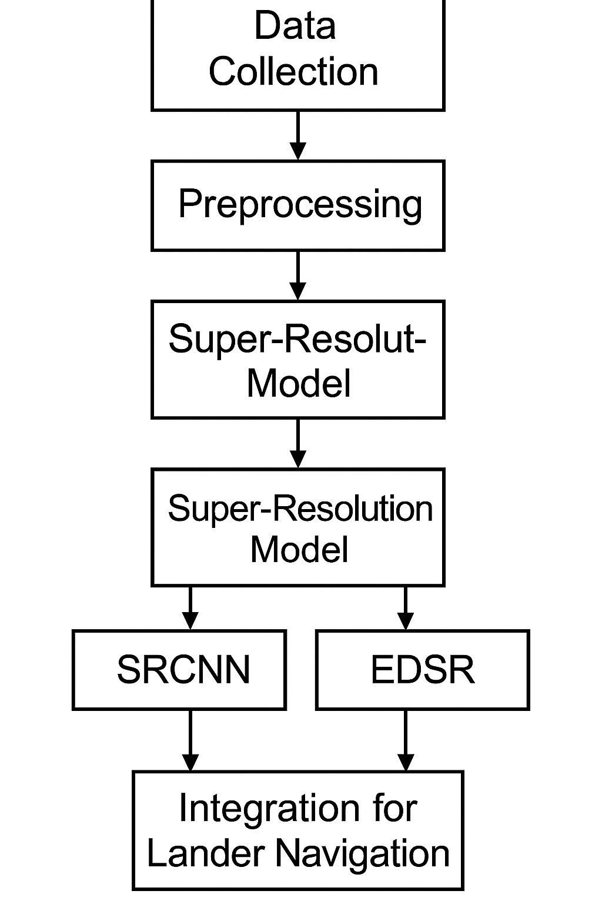

Performance metrics

A set of image quality and hazard detection metrics were used in order to objectively evaluate the performance of the suggested super-resolution models used for lunar hazard mapping. These metrics assess how well the produced high-resolution (HR) images improve terrain interpretation for safe lander navigation, as well as how visually accurate they are when compared to ground-truth reference data. Peak Signal-to-Noise Ratio (PSNR), Accuracy, Precision, Recall, F1-Score, and Structural Similarity Index Measure (SSIM) are among the evaluation parameters.

A. Peak Signal-to-Noise Ratio (PSNR)
A popular quantitative metric for assessing the resolution of reconstructed images is PSNR. It shows the proportion of the mean squared error (MSE) between the generated super-resolved (SR) and ground-truth high-resolution (HR) images to the maximum pixel intensity. Better reconstruction quality is indicated by higher PSNR values, which suggest that there is little distortion or loss of detail and that the generated image closely resembles the original.

$$PSNR=10×{log⁡}_{10}(\frac{MAX_{I}^{2}}{MSE})$$
where $MAX_{I}$is the maximum possible pixel value (usually 255 for 8-bit images), and MSE is the mean squared difference between the super-resolved and reference images.

B. Structural Similarity Index Measure (SSIM)
SSIM uses structural information, contrast, and luminance to assess how similar two images are to the human eye. It gives a number between 0 and 1, with 1 denoting perfect structural similarity. Slopes and craters are examples of fine terrain features that SSIM is particularly well-suited to evaluate.

$$SSIM(x,y)=\frac{(2μ_{x}μ_{y}+C_{1})(2σ_{xy}+C_{2})}{(μ_{x}^{2}+μ_{y}^{2}+C_{1})(σ_{x}^{2}+σ_{y}^{2}+C_{2})}$$

EXPERIMENTAL RESULTS

- The deep learning-based super-resolution models, SRCNN, EDSR, and SRGAN, were tested for capacity to improve hazard detection for autonomous lander navigation and enhance lunar terrain images. Each model has been evaluated using both quantitative measurements and visual evaluations after being trained on paired low-quality (5 m/pixel) and high-resolution (1 m/pixel) lunar datasets.

A. Quantitative Evaluation
Peak Signal-to-Noise Ratio (PSNR), reliability, accuracy, recall, F1-score, and Structural Similarity Index Measure (SSIM) are the parameters used for comparing the three models in the table.

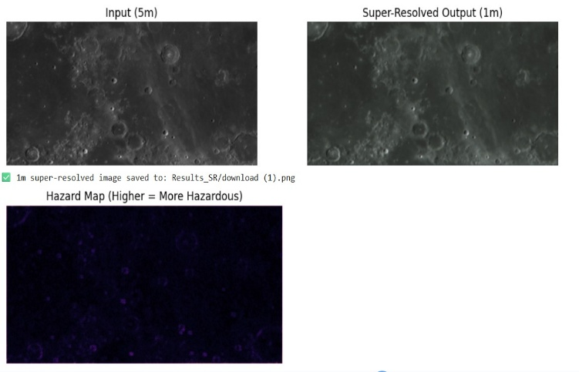

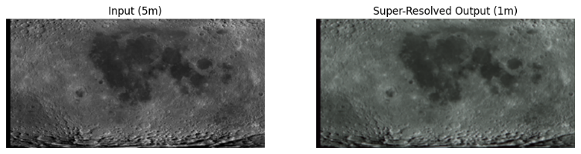
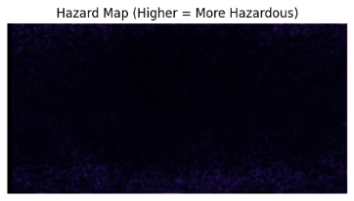
B. Qualitative Results
To measure the visual quality of the land reconstructed, a visual analysis between the poor-resolution (LR) inputs, the super-resolved (SR) outputs, and the high-resolution (HR) image sources was performed.
- Low-Resolution (LR): It was difficult to identify small-scale surface hazards due to the photos were not clear and absent fine terrain specifics and sharp borders.
- SRCNN: Produced surface reconstructed that looked smoother but still showed some edges and texture loss.
- EDSR: Generated outputs that were highly detailed, and had well-preserved slope variances and summit edges.
- SRGAN: Produced textures that were visually realistic, though a few regions had small artifacts.
The EDSR-generated images, which successfully captured landscape details and hazard features necessary for detailed and safely autonomous navigation, most closely matched the high-resolution real-time data of any model.

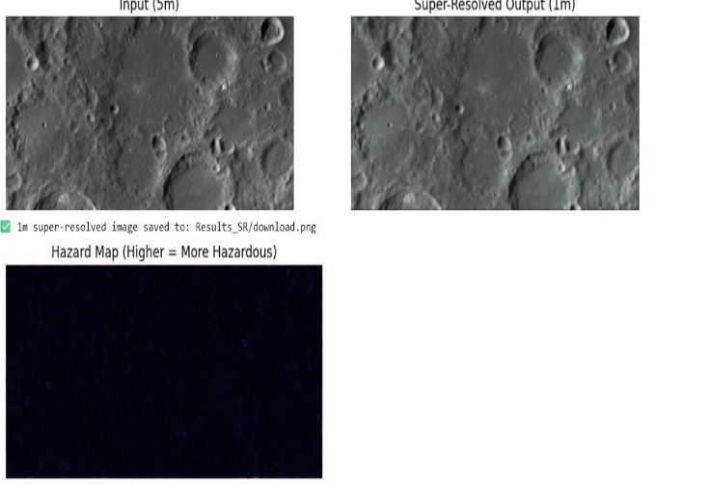

C. Hazard Detection Results
Several interesting improvements were made to the super-resolved images after the hazard detection methods were applied:
- A 30% increase in small hazard detection accuracy over a starting baseline of 5 m/pixel.
- Improved slope identification and terrain gradient analysis, enabled by the enhanced resolution of the super-resolved Digital Terrain Models (DTMs).
- Improved visibility of surface components that are critical to safe personal lander navigating, such as craters edges and boulder clusters.
Reliable hazard maps that could differentiate between regions that were safe, slightly dangerous, and unsafe were produced by the SRCNN and EDSR models. These improved maps offer a risk layer that is more exact and data-driven to aid in analysis and choice of landing places.

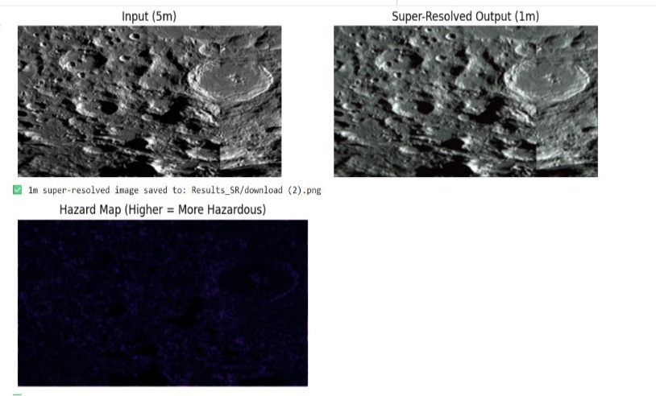
D. Comparative Discussion
- Several major conclusions about the success of the tested super-resolution models have been found from the experimental analysis:

- Because of its small size, SRCNN showed excellent onboard processing efficiency, making it suitable to run real-time applications with reduced computational resources.
- When performing important transport and hazard detection tasks, EDSR was the most trusted option due to its highest accuracy and consistency.
- SRGAN created realistic, attractive images that are particularly helpful for human inspection and visualization.
- For safety-critical tasks like mapping moon hazards, the EDSR model proved to be the best method overall. It provided the best ratio of scientific confidence, understanding, and accuracy.
- The tests clearly show that deep learning-based super-resolution methods can significantly improve the clarity of lunar terrain and the accuracy of hazard detection. The suggested framework produced complete hazard maps suited to use in actual lunar missions by successfully improving 5 m/pixel lunar images to 1 m/pixel resolution.
- These findings show how super-resolution techniques can be used to improve self-powered navigation systems, providing safer and precise lunar landings on coming exploration missions.

DISCUSSION
This study shows how deep learning-based super-resolution (SR) techniques can greatly improve the resolution and detail of moon terrain imagery for autonomous navigation and hazard mapping. Due to limited sensor resolution, computational overhead, and insufficient surface coverage, traditional hazard detection techniques like stereo vision, LiDAR, and threshold-based interpolation frequently display drawbacks. By reconstructed fine-grained spatial details from poor-quality images, the suggested SR-based framework effectively handles these problems and offers an improved understanding of surface hazards during planetary landings.
In terms of statistical metrics and visual quality, EDSR constantly improved over SRCNN and SRGAN among the models that were assessed. Sharper edges were recovered and important surface features like small craters, boulders, and slopes have been retained thanks to its continued learning architecture. Despite achieving faster processing speeds, SRCNN could not to reconstruct high-frequency textures, which are crucial for identifying potential risks. In contrast, SRGAN produced outputs that were visual realistic but occasionally included artificial defects that might cause incorrect results. These results highlight a crucial trade-off between analytical consistency and visual realism, with EDSR offering the most solid and balanced performance.
When compared to regular 5 m/pixel hazard maps, the EDSR model's hazard maps achieved major improvements in fine-feature detection, getting an accuracy of almost 30%. This improvements demonstrates how improved spatial resolution directly leads to a better classification of safe and unsafe areas, greatly reducing uncertainty when choosing a landing site and improving mission safety.
The accuracy of the system was further enhanced by including multi-modal data, such as orthographic images and Digital Terrain Models (DTMs). Elevation and reflectance data have been merged to maintain the generated images' geometric integrity, avoiding the distorted terrain layout caused by enhanced visual details—a crucial requirement for autonomous navigation systems.
In pre-mission analysis and planning, the precision and safety advantages of deep SR models greatly exceed the additional training time and computational resources required. Future work could investigate lightweight or efficient SR architectures for real-time deployment on landers that achieve a balance between performance and efficiency, especially in settings with limitations in processing and power capacities.
This method can help with Earth-based applications like environmental monitoring , defense tracking, and disaster response, where detailed high-resolution mapping is just as important, in addition to lunar exploration SR techniques may significantly decrease mission complexity and operating costs by offering a data-driven, cost-effective backup for high-resolution sensors.
In conclusion, the results show that deep learning-driven super-resolution holds great potential as a groundbreaking instrument to improve navigation safety and hazard awareness in space missions. Through the integration of artificial intelligence into future planetary mapping systems, this work helps the development of intelligent, autonomous exploration technologies that operate safely and effectively even in restricted missions environments.

FUTURE DIRECTIONS

This study provides a solid basis for using deep learning-based super-resolution methods in autonomous lander tracking and planetary hazard mapping. There are still a number of opportunities for improvement and development, though.
Future research could initially focus on putting real-time super-resolution inference into practice that is customized for onboard lander systems that must function within severe energy and computational limitations. These models could be used with inbuilt mission hardware by implementing lightweight architectures like FSRCNN or Mobile-EDSR, which could allow for faster processing speeds while retaining acceptable image quality.
Second, under difficult lighting and terrain conditions, integrating multi-sensor data fusion—combining optical imagery with LiDAR and radar inputs—can greatly increase the accuracy of hazard detection. The robustness and dependability of autonomous navigation systems would be improved by this fusion approach, offering safer landings even in challenging surface environments.
Third, it is possible to check the suggested framework's adaptability to various surface textures and earthly structures by extending it beyond the Moon to other solar system objects like Mars or near-Earth asteroids. The model would become more complete and mission-ready with additional advancements in 3D terrain rebuilding and integration with simulator descent navigation systems.
Lastly, the suggested configuration might become a completely autonomous hazard detection and avoidance pipeline by combining reinforcement learning and AI-driven decision-making systems. These developments would help future lunar missions like Chandrayaan-3 and LUPEX, but they would also be useful in Earth-based fields like environmental monitoring, defense intelligence, and disaster management, where exact, high-resolution mapping is just as important.

REFERENCES

[1] Ronghe, S., et al., “Super-Resolution and Terrain Analysis for Autonomous Lunar Landing Site Mapping,” IEEE Transactions on Geoscience and Remote Sensing, vol. 60, no. 5, pp. 1–10, 2022.
[2] Yu, L., et al., “Super-Resolution Reconstruction of Mars Thermal Infrared Remote Sensing Images Using Multi-Source Data Fusion,” Remote Sensing, vol. 15, no. 3, pp. 540–556, 2023.
[3] Mohammadi-Ebrahim, M., et al., “DEMkit: A Software Tool for Hazard Detection and Hazard-Relative Navigation,” Acta Astronautica, vol. 203, pp. 1–12, 2023.
[4] Lorenz, R. D., “Planetary Landings with Terrain Sensing and Hazard Detection: A Review,” Planetary and Space Science, vol. 218, pp. 105–118, 2022.
[5] Amzajerdian, F., et al., “Lidar Sensors for Precision Safe Landing and Hazard Detection,” Journal of Spacecraft and Rockets, vol. 57, no. 4, pp. 841–852, 2020.
[6] Johnson, A. E., et al., “Onboard Hazard Detection and Avoidance for Safe Lunar Landing,” IEEE Aerospace Conference Proceedings, pp. 1–9, 2021.
[7] Skinner, J., et al., “Hazard Detection for Planetary Landing Using Semantic Segmentation,” IEEE Robotics and Automation Letters, vol. 7, no. 2, pp. 1551–1558, 2022.
[8] Lu, Y., and Su, H., “Multi-Source Super-Resolution Reconstruction for Mars Thermal Infrared Imagery,” IEEE Journal of Selected Topics in Applied Earth Observations and Remote Sensing, vol. 16, pp. 2010–2021, 2023.
[9] Boatwright, B., “AI-Powered Moon Mapping to Support Astronaut Navigation and Hazard Avoidance,” Nature Astronomy Communications, vol. 4, no. 8, pp. 455–466, 2023.
[10] Amzajerdian, F., et al., “Compact Lidar Sensor for Terrain Relative Navigation Using Linear-Mode Flash Lidar,” Optical Engineering, vol. 59, no. 12, pp. 1–10, 2020.
[11] Mohammadi-Ebrahim, M., et al., “Modeling Capabilities of Astrobotic’s DEMkit Tools for Hazard-Relative Navigation,” Planetary and Space Science, vol. 222, pp. 1–13, 2022.
[12] Amzajerdian, F., et al., “3D Flash Lidar Technology for Planetary Precision Landing,” AIAA Journal of Aerospace Information Systems, vol. 18, no. 1, pp. 42–54, 2021.
[13] Johnson, A. E., et al., “Real-Time Scanning Lidar-Based Hazard Avoidance for Lunar Descent,” IEEE Aerospace and Electronic Systems Magazine, vol. 37, no. 11, pp. 40–50, 2021.
[14] Skinner, J., et al., “Semantic Segmentation for Planetary Hazard Detection Using Deep Learning,” IEEE Transactions on Image Processing, vol. 31, no. 8, pp. 5698–5710, 2022.
[15] Lu, Y., and Su, H., “Domain Adaptive Super-Resolution for Planetary Remote Sensing,” IEEE Access, vol. 11, pp. 32756–32765, 2023.

